*KMS for ABET compliant teaching and evaluations*

Muhammad Haris Khan

MS (Computer Science)

A thesis submitted in partial fulfillment of the requirements for the degree of Master of Science



Department of Computer Science

National University of Computer and Emerging Sciences

2015

*KMS for ABET compliant teaching and evaluations*

Submitted by: Muhammad Haris Khan (13k-3007)

Colloquium: 12.04.2015 - Spring 2015

|  |  |
| --- | --- |
| Supervisor: Sir. Nadeem Kafi | Signature: |

Department of Computer Science

National University of Computer and Emerging Sciences

Karachi Campus

**Declaration of Originality**

*KMS for ABET compliant teaching and evaluations*:

I certify that this work is free of plagiarism and all materials appearing in this report have been properly quoted and attributed.

Further, I certify that I am the sole author of this report and that no part of this report has been published or submitted for publication.

I declare that this is a true copy of my report, including any final revisions, as approved by my supervisor and the thesis committee, and that this report has not been submitted for a higher degree to any other University or Institution.

______________________________________

Name and Signature of the Student

______________________________________

Date (day/month/year)

**Acknowledgements**

I take this opportunity to express our profound gratitude and deep regards to my Supervisor Sir.Nadeem Kafi for his exemplary guidance, monitoring and constant encouragement throughout the coarse of Project. The blessing, help and guidance given by him time to time shall carry me a long way in the journey of life.

I am also obliged and express a deep sense of gratitude to our Head of the department (Computer Science) Dr. Jawwad Shamsi for his cordial support and by his personal interest. I am highly indebted to my Institute FAST-NU which is doing its best in the professional field of Computer Sciences.

Lastly, I thank Almighty Allah, my parents, and friends for their constant encouragement without which this project would not be possible.

**Abstract**

Our expert system will suggest the improvement plan; the industry experts will train this software by setting the rules in our system. The teachers may also use this system to design the exams, this software will contain a questions bank along with the experts suggestions (e.g. in which type of exam a question should be used etc.). This software will consist of a website which will be available over the internet. We will build this software on Asp .Net framework.

**Table of Contents**

Contents

Chapter 1 - Introduction 7

Chapter 2 - Related Work 10

Chapter 3 - Methodology 15

Chapter 4 - Results 45

Chapter 5 - Conclusions and Future Work 46

Chapter 6 - References 47

# Chapter 1 - Introduction

Processes to ensure continuous improvement of the quality of a system are called Continuous Quality Improvement (CQI) processes. Academic programs require CQI to attain a certain level of satisfaction of the learning outcomes. These processes are required for a program to be accredited by ABET or other similar accrediting agencies (Prof. Dr. Imam & Prof. Dr. Tasadduq, 2012). While expert system technologies have been successfully developed and deployed in such diverse disciplines as Engineering, Business, Mining, Medicine, etc. (Ahmad et al 2008; Marakas, 2013; Negnevitsky, 2013; Turban and Aronson, 2013), little efforts have been expended in employing decision support and expert system methodologies in the important area of CQI/Accreditation.

The idea of integrating expert system with the question bank is new. The expert system developed in this project will help the faculty members in designing assessments and suggesting continuous improvement plans for courses in which the required satisfaction is not achieved. The expert system will be dynamic with a knowledge base that will continue to grow with time as more and more knowledge and rules are added to it. Hence we named this project as Knowledge management system (KMS) for ABET compliant teaching and evaluations.

The expert system for improvement of the teaching a course has not been implemented earlier. For CQI, there will be a knowledge base containing rules added by the industry experts. Each rule will be associated with a single CLO (course learning outcome) and each rule yield suggestion(s) for that CLO. The multiple choice questions (MCQs) will be presented to instructor and his/her answers will be processed in an inference engine which will output the suggestion(s) based on the provided rules added by the industry experts.

Secondly, in this project we would develop an expert system for helping the instructors in selecting the appropriate questions for any type of assessment (in the form of /quizzes/ home works/Midterm/ Final Exams/ term projects etc) of the course. Presently there is no systematic or consistent way for manually designing the type of assessment for which the proposed expert system is required. For the proposed expert system, we are talking about the assessment of learning outcomes. Mostly instructors don’t design assessments for learning outcomes. Usually the manual design of assessments focuses on the assessment of the topics or subtopics covered in a course. The idea of an expert system for assessment of learning outcomes of a course which is the root of the CQI and a necessary requirement of ABET Accreditation, is new.

While manually designing the assessment, the instructor thinks and based on his own judgment, selects a question from the set of questions available to him for the course, or he makes a new question and adds it to the list of questions. The expert system we are proposing will do the inferencing based upon the following:

A set of technical questions for each subtopic (developed initially and then improved gradually in quantity and quality based on the data gathered from the use of the expert system )

Each question will have a set of attributes as follows:

1. Learning outcome IDs (may be more than 1) that it can test
2. Bloom’s Level
3. Time needed to solve
4. How strong is the question in assessing the learning outcomes in (i) above e.g. 10%, 50% or 100% etc
5. Topic/Subtopic it addresses
6. A set of questions that the expert system interface will ask the instructor
7. Possible answers of each question in ( c )

A set of If-then-else rules to select the right technical question from the set of questions in (a).

An expert system is a computer system that emulates the decision-making ability of a human expert. Expert systems are designed to solve complex problems by reasoning about knowledge, represented primarily as if–then rules rather than through conventional procedural code. An expert system is divided into two sub-systems: the inference engine and the knowledge base. The knowledge base represents facts and rules. The inference engine applies the rules to the known facts to deduce new facts.

The CQI and accreditation processes of engineering education could have potential applications of knowledge-based expert systems. One such area is the “assessment design” for a specific learning outcome. In this case, the instructor, in a course he/she is teaching, can select the most suitable question(s) for assessing a global learning outcome (e.g., student outcome in ABET terminology) or one of the course learning outcomes. A knowledge base may be built having a variety of questions for each topic or subtopic of the course. Each question can have tags indicating the learning outcome it addresses, time needed to solve the question, level of difficulty, and Bloom’s Level etc. A set of if/then/else rules may also be developed and incorporated in the knowledge base. The inference engine will interact with the knowledge base and respond to the user by suggesting appropriate questions for the assessment as shown in Fig. 1.

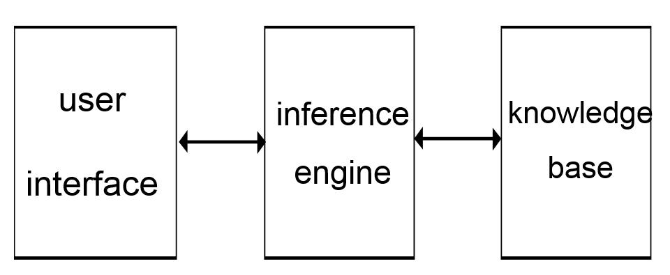

Fig. 1: A typical expert system

Another potential application of expert system in the context of CQI/Accreditation may be in the treatment of a weakness in a particular learning outcome. If at the end of a course, it is found that the satisfaction criterion for an outcome has not been achieved e.g., less than 70% students are able to obtain more than 70% marks in a particular learning outcome, a continuous improvement plan is required to improve the situation when the course is taught next time. The possible treatments may include, more homework, more quizzes, arranging tutorials, re-sequencing the order of topics taught, toughening the admission policy, etc. Similar other areas of possible application of expert system may be explored.

ABET is a non-profit and non-governmental accrediting agency for academic programs in the disciplines of applied science, computing, engineering, and engineering technology. ABET is a recognized accreditor in the United States (U.S.) by the Council for Higher Education Accreditation.

ABET accreditation provides assurance that a college or university program meets the quality standards established by the profession for which the program prepares its students. ABET accredits postsecondary programs housed in degree-granting institutions which have been recognized by national or regional institutional accreditation agencies or national education authorities worldwide.

Each course has a set of outcomes called “Course Learning Outcomes” or CLOs. The CLOs of a course describe the abilities to be attained at the end of the course. The CLOs for each course are specified so that they are non-overlapping and are as few as possible still covering the specified syllabus of the course. An example and a typical set of CLOs is shown in Table 2-1 for the course 803331 Hydraulics (Chapter 4 - Self Study Report UQU Civil Engineering Program):

Table 2-1: Typical CLOs (803331 Hydraulics)

|  |  |
| --- | --- |
| CLO ID | CLOs |
| CLO 1 | Ability to calculate flow in water distribution systems and design networks |
| CLO 2 | Ability to analyze flow in different types of open channels |
| CLO 3 | Ability to conduct flow measurement experiments in pipes/open channels |
| CLO 4 | Ability to use computer software in network design |
| CLO 5 | Ability to design and select different types of pumps |

**Knowledge Management usage in CQI Expert System**

In Continuous Quality Improvement (CQI) and Question Bank for different courses as per the ABET policies, the knowledge management will play an important role for the better achievement of the goals. We may have different techniques of Knowledge Management incorporated in our system like, push and pull notifications; when a teacher is feeling interest in some topic or course s/he may have the option to subscribe for the topic/course, so s/he will get the instant notification for the changes/events for this topic/course. If a user teaching/taught a course and needs some ideas to improve the course, s/he may send notification(s) to the pool of teacher to seek their input. The pool of teacher may be created in our system in such a way that any teacher may create a group and invite teacher(s) for this group; they may accept/reject the invitation.

Another aspect is of voting/recommendation that if a teacher adds a question in our system, a notification will be sent to all the teachers of the same faculty/department. Other teachers of same faculty or department may vote up or vote down the added question, may recommend the same question for some topic or some type of exam (types of exam are quiz, assignment, midterm, final, project etc.). They may comment on the added question as well.

We may have a dashboard for our system which will be shown when user logins to the system. The user may see the notifications related to the different courses/topics for the teacher has subscribed for and/or some teacher asked help for some course/topic.

# Chapter 2 - Related Work

I read the research paper of Knowledge Management in Health care systems [3]. They were working for the field of medicine and we are working on the project for education and rules for teaching proposed by ABET. Our basic focus is for incorporating the KMS aspects in the Expert system of ABET compliant teaching project while their focus was on the integration of many small already development systems into one system for better Knowledge Management. They also explained the good background information about Knowledge Management which summary is as follows:

**Knowledge Management Cycle**

The knowledge management cycle, consists of four processes namely:

1. Knowledge creation
2. Knowledge structuring
3. Knowledge dissemination
4. Knowledge application

**1. Knowledge creation**

Knowledge can be created from several sources and methods such as R and D center, organizational learning outcomes, lessons-learned analysis and innovation.

**2. Knowledge structuring**

The knowledge structuring process includes deﬁning, storing, categorizing, indexing, and linking digital objects such as documents and images to knowledge units. Mapping the existing and available knowledge (including expertise and skills) in terms of its context, relevance, and locations helps in the classiﬁcation of the knowledge into taxonomies. Devising a classiﬁcation system is the key to building knowledge taxonomies.

**3. Knowledge dissemination**

The knowledge dissemination process primarily involves knowledge sharing and collaboration. This includes searching for (pulling) and subscribing to (pushing), automatically relevant content to users on the basis of their needs and interests.

**4. Knowledge application**

The knowledge application process involves applying, which includes retrieving and using, knowledge in support of decisions, actions, problem solving etc.

**Knowledge Management Capabilities**

In order to implement the aforementioned four processes to create the knowledge environment, organizations need to provide and support several categories of knowledge management capabilities through the deployment of currently available technologies.

The capabilities framework, at a high level, can be explained in two parts:

1. First, it is designed to leverage existing knowledge and to enable creation of new knowledge through a continuous learning process denoted by the knowledge learning loops.
2. Secondly, the capabilities component is denoted by the rectangular, labeled boxes.

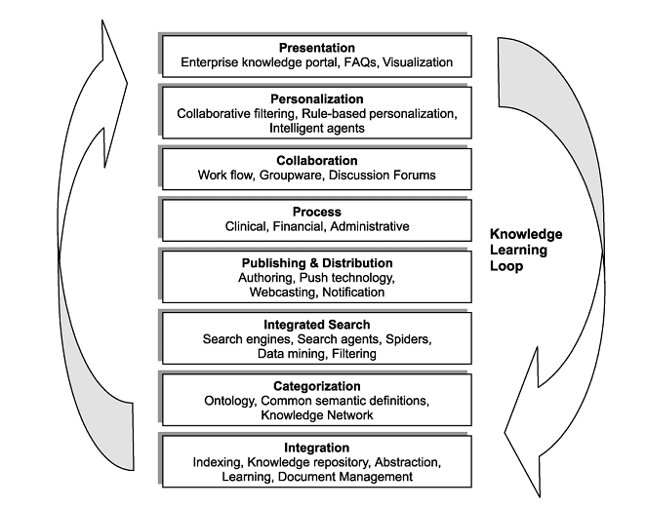

Presentation involves personalizing both the access to and displaying the results of user interactions with the system. It is designed to let every organizational user know where to go to find the organization’s knowledge through a single browser-based point of entry to all information that the user needs.

Personalization provides the ability to customize what type of information is relevant to a user and how that information is presented. The primary capabilities of this function include creation of personalization profile of individual users or groups or departments or divisions, providing personalized navigation and notification; and the ability to personalize the content categorization. Personalization is often accomplished by using software agents, commonly called spiders, to get the information and handle user profiling.

The collaboration function is designed to connect people with people through communities of practices; to preserve the discussions; and to stimulate collaboration by integrating the knowledge repositories and collaboration applications such as workflow.

The process function allows users to participate in relevant business processes in the context of their own roles. Through this function, users have access to knowledge management applications such as knowledge or evidence based decision support system applications that enable increased responsiveness to customers and partners.

The publishing and distribution function uses Software agents. The users can specifyin software agents the type of knowledge he or she wants to publish,distribute, and receive. The frequency (by time and/orquantity) and method (by e-mail orWeb page) are importantparameters that should be set up.

The integrated search function is designed to reduce theinformation overload. Users can also identify the repositories theywant to search such as Web pages, e-mails, and discussions.This function should provide the ability of indexing and to crawl frequently to keep the index current.

The categorization function allows users to browse,create, and manage knowledge categories. It establishes aprocess and guidelines forauthoring and publishing knowledge categories by the users. Business groups or departments are made responsible for creating andmanaging their own subject area taxonomies.

The integration function ensures seamless and consistent navigation among and between the above functions and knowledge sources such that all individuals can use the organization’s combined knowledge and experience in the context of their own roles.

**Proactive knowledge based decision-support**

Two types of problems originate from it:

1. Inconsistent Knowledge: The first problem is that knowledge is fragmented, not shared, and thus inconsistent. E-health requires a better DSS repository to have access to and to analyze the enterprise-wide knowledge for business intelligence.
2. Inconsistent Knowledge bases**:** The second problem is technical in nature. The multiple knowledge bases used in different environments make sharing of knowledge more complex it therefore introduces complexity in developing Decision Support System (DSS) front ends.

The solution strategy to the above integration problem is to design and develop a logical enterprise knowledge warehouse (EKW). The EKW would require knowledge to be pieced together from various systems and sources, merged into a cohesive whole, and made available to all those who need it. The EKW is therefore a managed knowledge base in which the knowledge is subject-oriented, integrated, time-variant, and non-volatile. In addition, EKW is designed to provide consistent knowledge for DSS.

I read another research paper of Outcome based teaching and learning in Computer Science Education in Sub-degree program [2]. They implemented the outcome based teaching and learning paradigm in sub-degree program at China, and found the improvement and good results then older taught courses. They implemented in 4 courses, and provided results for 2 courses; in both courses the capabilities of the students were more than past and they were highly motivated to implement the same technique in future courses. The difference between them and our project is that they implemented the Outcome based teaching and learning in the courses taught in their institute and we are making a software which will help the teachers in improving the Outcome based teaching in the courses taught by them.

The research paper also provided background information about Outcome based teaching and learning techniques which are as follows:

Definition of Learning Outcome is “Learning outcomes are statements that specify what learners will know or be able to do as a result of a learning activity. Outcomes are usually expressed as knowledge, skills or attitudes.” And “A learning outcome is a written statement of what the successful student/learner is expected to be able to do at the end of the module/course unit or qualiﬁcation.”

In learning outcome based teaching paradigm, instead of simply teaching all the related topics to students so that they know how to create an array with pointers? or should we expect the students to be able to create a point of sales (POS) system with multiple commands? The second option of creating a point of sales (POS) is outcome based approach which enables a student to build an interactive real world application. What is taught plays no meaning if a certain ability of students is not expected at the beginning of a course. That is the reason that the ”Outcome-based approach” is brought forth and introduced to every educator.

In order to guarantee that students achieve certain outcomes, the curriculum design needs to be as speciﬁc as possible so that the expectation can be easily reached. Many people may think that the organization of the assessment data using OBA can take longer time than usual. Teaching and learning under this framework focuses on the expectation of students after their completion of the program studies, what they are expected to learn and perform, rather than what the teacher expects to teach and present. Once the objective is shifted to the student-oriented approach, the quality skills of graduates are expected to be further enhanced. And also the job oriented approach so that students are expected to learn skills which are essential for their jobs. Lectures, tutorials, seminars, case studies, guest talks, and projects are provided to students so that they have opportunities to learn from real examples and then practice on their own while creating a course project/assignment. In addition, problem-solving skills are developed through applying a range of techniques and ideas in handling business problems. On the program level, the OBA framework suggests that all the course learning outcomes should point to the ultimate objective outcomes in the program studies.

Assessment becomes more clearly explained because students expect what they need to learn and do upon the completion of the course. Students overall feel their progress in developing intellectual skills through the course as the outcomes and objectives are clearly stated in the course syllabus as well. Bloom’s taxonomy is commonly used for writing learning outcomes give the beneﬁts of its ready-made structure and list of verbs. All of these verbs are measurable, meaning an appropriate assessment activity can effectively measure whether a student has achieved the learning outcome.

I studied a research paper Creating and Coding an Expert System in VB .Net [4], they implemented an expert system for loan management system. It is a research paper which provides a hand on experiment on developing an Expert System in VB .Net. We are also developing an expert system with the capabilities of Knowledge Management in it. And we are developing a software for improvement in courses and a question bank for ABET compliant teaching while they worked for Loan Management system.

In Self Study report of Umm-ul-qura university for Civil Engineering department [1], they implemented the ABET compliant teaching and learning outcome based teaching in their Civil Engineering department. This report provides an implementation of the outcome based teaching and learning in the department. This report explains how the learning outcomes are set for a course, how the student outcome is set for degree program of Civil Engineering department. They also point out that they used the CLOSO software for maintaining the ABET compliant teaching data in Civil Engineering department. This software takes input of the data of the course exams in learning outcome pattern and then finally output the student outcome at the end of the degree. This software is different with our project in the sense that it takes data and generates report for learning outcome and our software will use this data for improvement in courses which will be taught in future. And our project will also have a question bank which will allow the teachers to design the exams more efficiently as well.

# Chapter 3 - Methodology

Our project is a web based project which will be available over the internet. The users may use it on any browser, any operating system or any kind of device (i.e. desktop PC, tablet PC or smart phones etc.).

Each course in academic programs has a set of learning outcomes that may be called “Course Learning Outcomes (CLO)”. To maintain the quality of education and Continuous Quality Improvement (CQI), it is important to assess the students for these CLOs. For university level academic programs, each course has several CLOs. For improvement purpose the industry experts will create rules and each rule would yield suggestion(s). Each rule will be associated with a single CLO.

For e.g. a rule can be:

If:

1. Less than 70% of students get less than 70% of marks in CLO of “Ability to design and select different types of pumps” for course of Hydraulics.
2. Two questions were asked in the quizzes for the CLO
3. One assignment was given for the CLO
4. Two questions were asked in Mid Term Exam for the CLO
5. Three questions were asked in Final Exam for the CLO

Then:

* “Give one more assignment and/or a small class room activity for better understanding of CLO”.

For Adding a rule there would be questions which will be added in the database. These questions will be multiple choice questions and these questions along with their choices will also be added by the industry experts. Each question will be associated with single CLO.

For e.g. a question can be:

* How much percentage of the students get less than 70% of the marks in the CLO of “Ability to design and select different types of pumps” for course of Hydraulics?

The choices may:

1. Less than 85% of the students
2. Less than 70% of the students
3. Less than 60% of the students
4. Less than 50% of the students
5. Less than 40% of the students

When an instructor wants to suggest an improvement in a CLO, set of these questions will be presented to the instructor along with their choices. The instructor will pick a choice or skip the question. When all the questions have been presented and asked from the instructor, an inference engine will process the answers of the instructor and suggest the improvement based on the rules suggested by the experts.

The system will automate the process by having following data:

1. CLOs (course learning outcomes)
2. Instruction methods (lectures, videos tutorials etc.)
3. Assessment methods (quizzes, assignments, midterm exams or final exams etc.)
4. Assessment mark distribution
5. Assessment CLO mapping
6. Student list (their name, student id etc.)
7. Student’s assessment marks

Rather than asking/presenting the rule based questions for above details from instructor, system will calculate the values from the stored data in database. Like for calculating “How much percentage of the students get less than 70% of the marks in a given CLO” the system will calculate the percentage of students who get less than 70% of the marks from the Student’s assessment marks (in point 7), Assessment mark distribution (in point 4) and Assessment CLO mapping data (in point 5). Now only those rule based questions which are open ended will be presented to instructor for suggesting the improvement.

Following use case diagram shows 12 major operations for Continuous quality improvement plan for courses as shown in Fig. 2

1. Ask Improvement suggestions from Expert System
2. CRUD (create/read/update/delete) programs
3. CRUD courses
4. CRUD CLOs associated with the courses
5. CRUD rule
6. CRUD questions for rules
7. CRUD instruction methods
8. CRUD assessment methods
9. CRUD Assessment mark distribution
10. CRUD Assessment CLO mapping
11. CRUD Student list (their name, student id etc.)
12. CRUD Student’s assessment marks



Fig. 2: Continuous Quality Improvement for Course Learning Outcomes – use case diagram

The proposed expert system should help the instructor in selecting a question for assessing a given CLO. With this core ability required in the expert system, the following basic elements will be required:

1. A pool of questions for a given course has to be developed for each course. In this pool of question, each question will have a set of attributes. These attributes are as follows (more may be added):
2. Pre-requisite course topics for this question
3. Bloom’s Taxonomy level of the question
4. The CLO(s) addressed by the questions
5. Percentage weight of each CLO addressed by the question
6. Average time required by the student to answer the question
7. Question Type (MCQ, T/F, Numerical, Descriptive)
8. Does the question require the student to draw a figure (yes or no)
9. The expert system will interact with the instructor with a set of queries to determine the instructor’s preferences for selecting a question. For example, expert system will ask what Bloom's Taxonomy Level is required for the assessment. Similarly all attributes will be presented to the instructor with choices.
10. A rule base will relate instructor’s response to a set of questions in the questions pool.
11. Using the rule base a proper set of suitable questions will be selected and presented to the instructor.
12. A software based on the above ideas will have proper interfaces to interact with the instructor. Instead of asking questions in text, a user friendly interface will show possible answers and the user will just have to choose from the choices.

Moderator (or Head of the department) will have the option to add/update/delete an attribute (stated in point a) for the question.

Following use case diagram shows 4 major operations for Knowledge base for questions as shown in Fig. 3

1. CRUD a set of questions (favorite list) from a pool of questions of our system
2. CRUD a new attribute for the question
3. CRUD a new question in the pool of question
4. CRUD comments on added question



Fig. 3: Knowledge base for Questions – use case diagram

The user will have an interface for interacting with our expert system. The teacher will create a favorite list which would be empty initially; the teacher will add questions in the favorite list by selecting questions from the proposed set of questions suggested by expert system. The system will show a list of program and then list of course to the teacher, the teacher will select a program name and then a course name respectively in order to create a favorite list. There may be many favorite lists specific for a course. Logically a favorite list may belong to a quiz, midterm, or final exam etc. but there is no actual binding imposed by our system. The system will ask different questions to the teacher for the attribute’s values. The expert system’s inference engine will process the teacher’s answer(s) and then formulate the recommendation of a set of questions to the teacher. The teacher will pick some/all of the questions from the recommended set of questions.

Another feature of the system will be available for the teachers to view the saved list. The teacher will ask the system to show the list of Favorite list saved by that teacher. The system will show a list of saved Favorite list to the teacher. Teacher will pick a Favorite list to view the questions saved in that Favorite list. System will show the list of questions for the Favorite list.

Another feature of the system will be available for the user to add a new question in the expert system. Only privileged teachers will be able to add a new question and after the moderator’s consent. The moderator may be head of the department for the particular course or some other more privileged teacher. When a teacher would be adding a new question inside the expert system, the system will ask the teacher to tell entire attribute’s values (defined in (point a)) for each question. When the moderator will accept the new added question then this question will be added in the pool of the questions in our expert system. Otherwise if the moderator rejects the new added question then the question will be deleted from the system.

Another feature would be adding comments/suggestions on the new added question. This feature will be available to the teachers of the same faculty. This feature would be available for two or three days to the teachers. After which the moderator (or head of the department) will approve or disapprove the question to be added in the question bank. This feature is for the part of KMS, in which peer evaluate and give suggestions for a new task, and all the suggestions are listed; so that some new suggestion may come in mind by viewing the list of suggestion.

At the completion of this project we may deploy this project on Azure Cloud platform of Microsoft. We have proposed an architecture for the deployment of Azure Cloud:

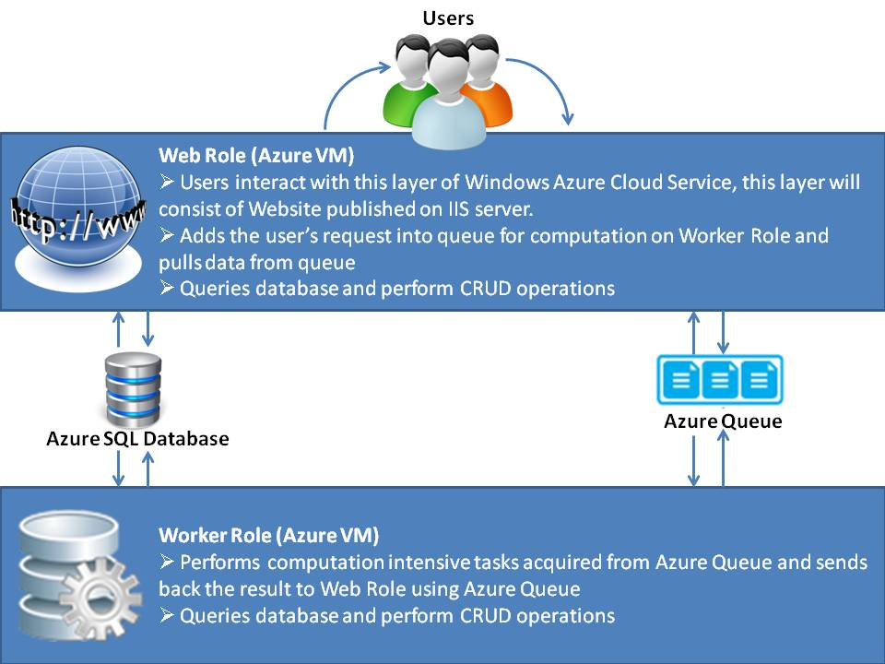Fig. 4: Architecture Diagram for Azure Cloud deployment

I made the above design as a hybrid/semi 3 tier architecture because of following reasons:

1. The Azure Queue don't have the option of returning some value/object when a message is read; like we have in SOAP and REST web-services i.e. calling a function/url may return some value as well as may take some value/object as an argument in the message.
2. In Azure Queue a message may be read more than one times, we may avoid this by assigning some id to each Queue message and on read checking whether the message id has been processed or not, but this is not feasible solution.

Following section describes the details of each screen and the database schema and data dictionary.

# Application Data

## Add a program

This screen will be available to the admin. The user will add a program for the university.

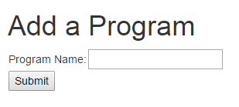

### Screen Fields

|  |  |  |
| --- | --- | --- |
| Field Name | Mandatory | Type |
| Program Name | Yes | Text |

### Screen Actions:

|  |  |
| --- | --- |
| Action Name | Action to Perform |
| Submit | This button will create a new program in the database |

## Add a Course

This screen will be available to the admin. The user will add a course for the program.

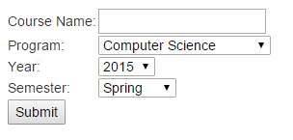

### Screen Fields

|  |  |  |
| --- | --- | --- |
| Field Name | Mandatory | Type |
| Course Name | Yes | Text |
| Program Name | Yes | Drop down selection |
| Year | Yes | Drop down selection |
| Semester | Yes | Drop down selection |

### Screen Actions:

|  |  |
| --- | --- |
| Action Name | Action to Perform |
| Submit | This button will create a new course in the database |

## Add a CLO

This screen will be available to the admin. The user will add a CLO for the course.

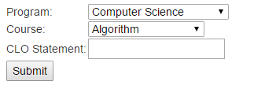

### Screen Fields

|  |  |  |
| --- | --- | --- |
| Field Name | Mandatory | Type |
| Program Name | Yes | Drop down selection |
| Course Name | Yes | Drop down selection |
| CLO Statement | Yes | Text |

### Screen Actions:

|  |  |
| --- | --- |
| Action Name | Action to Perform |
| Submit | This button will create a new CLO in the database |

## Add an Instruction Method

This screen will be available to the admin. The user will add a instruction method for the course.

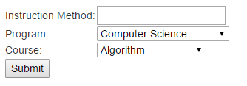

### Screen Fields

|  |  |  |
| --- | --- | --- |
| Field Name | Mandatory | Type |
| Program Name | Yes | Drop down selection |
| Course Name | Yes | Drop down selection |
| Instruction Method | Yes | Text |

### Screen Actions:

|  |  |
| --- | --- |
| Action Name | Action to Perform |
| Submit | This button will create a new instruction method in the database |

## Add an Assessment Method

This screen will be available to the admin. The user will add a assessment method for the course.

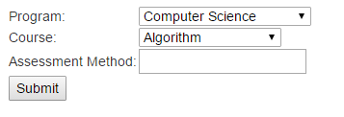

### Screen Fields

|  |  |  |
| --- | --- | --- |
| Field Name | Mandatory | Type |
| Program Name | Yes | Drop down selection |
| Course Name | Yes | Drop down selection |
| Assessment Method | Yes | Text |

### Screen Actions:

|  |  |
| --- | --- |
| Action Name | Action to Perform |
| Submit | This button will create a new assessment method in the database |

## Assessment Score Distribution

This screen will be available to the admin. The user will assign the score to the assessment methods.

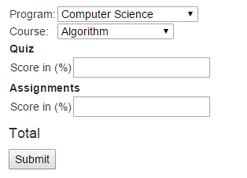

### Screen Fields

|  |  |  |
| --- | --- | --- |
| Field Name | Mandatory | Type |
| Program Name | Yes | Drop down selection |
| Course Name | Yes | Drop down selection |
| Assessment Method | Yes | Label |
| Score in (%) | Yes | Text |

### Screen Actions:

|  |  |
| --- | --- |
| Action Name | Action to Perform |
| Submit | This button will store the score distribution for assessment methods in the database |

## Add an Assessment

This screen will be available to the admin. The user will add an assessment for the course.

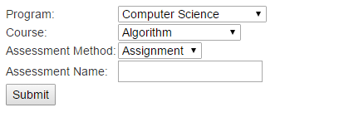

### Screen Fields

|  |  |  |
| --- | --- | --- |
| Field Name | Mandatory | Type |
| Program Name | Yes | Drop down selection |
| Course Name | Yes | Drop down selection |
| Assessment Method | Yes | Drop down selection |
| Assessment Name | Yes | Text |

### Screen Actions:

|  |  |
| --- | --- |
| Action Name | Action to Perform |
| Submit | This button will create a new assessment in the database |

## Assessment Score Distribution

This screen will be available to the admin. The user will assign the score to the assessment.

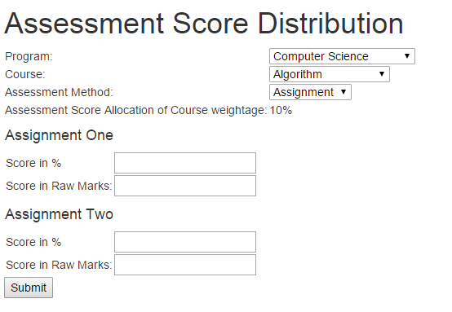

### Screen Fields

|  |  |  |
| --- | --- | --- |
| Field Name | Mandatory | Type |
| Program Name | Yes | Drop down selection |
| Course Name | Yes | Drop down selection |
| Assessment Method | Yes | Drop down selection |
| Assessment Score Allocation of the course weightage | Yes | Label |
| Score in (%) | Yes | Text |
| Score in Raw Marks | Yes | Text |

### Screen Actions:

|  |  |
| --- | --- |
| Action Name | Action to Perform |
| Submit | This button will store the score assignment for assessment in the database |

## Add an Question for Assessment

This screen will be available to the admin. The user will add an assessment for the course.

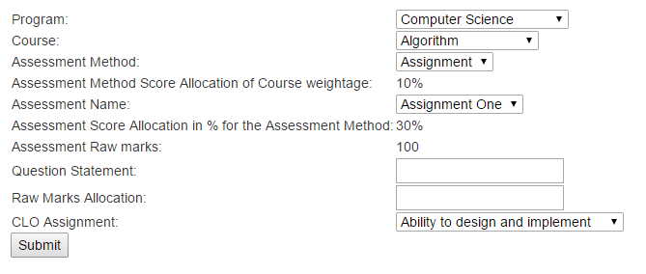

### Screen Fields

|  |  |  |
| --- | --- | --- |
| Field Name | Mandatory | Type |
| Program Name | Yes | Drop down selection |
| Course Name | Yes | Drop down selection |
| Assessment Method | Yes | Drop down selection |
| Assessment Method Score Allocation of Course Weightage | Yes | Label |
| Assessment Name | Yes | Drop down selection |
| Assessment Score Allocation in % for Assessment Method | Yes | Label |
| Assessment Raw marks | Yes | Label |
| Question Statement | Yes | Text |
| Raw Marks Allocation | Yes | Text |
| CLO Assignment | Yes | Drop down selection |

### Screen Actions:

|  |  |
| --- | --- |
| Action Name | Action to Perform |
| Submit | This button will create a new question in the database |

## Add a Student

This screen will be available to the admin. The user will add student for the course.

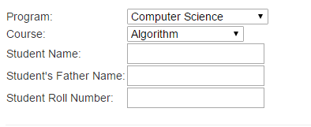

### Screen Fields

|  |  |  |
| --- | --- | --- |
| Field Name | Mandatory | Type |
| Program Name | Yes | Drop down selection |
| Course Name | Yes | Drop down selection |
| Student Name | Yes | Text |
| Student Father Name | Yes | Text |
| Student Roll Number | Yes | Text |

### Screen Actions:

|  |  |
| --- | --- |
| Action Name | Action to Perform |
| Submit | This button will create a new student in the database |

## Assessment Marks Allocation to Student

This screen will be available to the admin. The user will assign the marks to the assessment for the questions in an assessment.

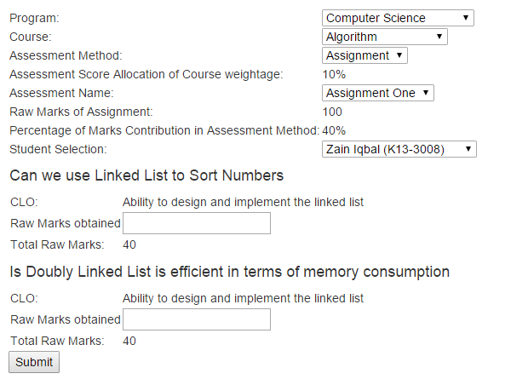

### Screen Fields

|  |  |  |
| --- | --- | --- |
| Field Name | Mandatory | Type |
| Program Name | Yes | Drop down selection |
| Course Name | Yes | Drop down selection |
| Assessment Method | Yes | Drop down selection |
| Assessment Score Allocation of the course weightage | Yes | Label |
| Assessment Name | Yes | Drop down selection |
| Raw Marks of Assessment | Yes | Label |
| Percentage of marks allocation in the assessment | Yes | Label |
| Student Selection | Yes | Drop down selection |
| Question Statement | Yes | Heading |
| CLO Statement | Yes | Label |
| Raw marks obtained | Yes | Text |
| Total raw marks | Yes | Label |

### Screen Actions:

|  |  |
| --- | --- |
| Action Name | Action to Perform |
| Submit | This button will store the score allocation for assessment to the student in the database |

# Improvement Plan

## Use case - Add a rule question

The user will add a rule question first then will add answers related to the added rule question.

## 

## Add a rule question

This screen will be available to the experts. The user will add a rule question for the rules of expert system.

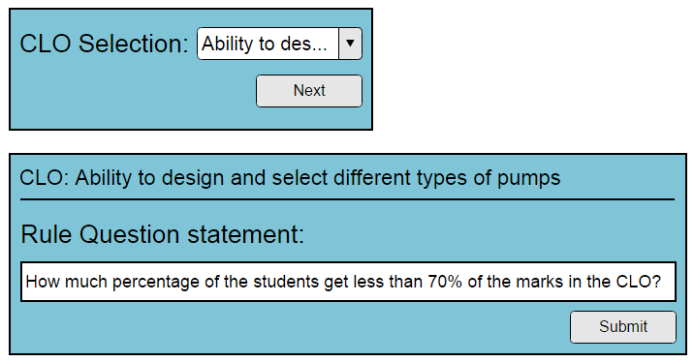

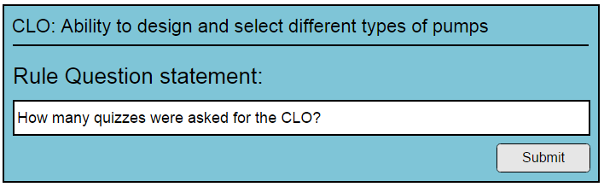

### Screen Fields

|  |  |  |
| --- | --- | --- |
| Field Name | Mandatory | Type |
| CLO | Yes | Drop Down Selection |
| Rule Question statement | Yes | String |

### Screen Actions:

|  |  |
| --- | --- |
| Action Name | Action to Perform |
| Submit | The use will be taken to the screen of rule question's answer. There the user may add answer's option for the question. |

## Add a rule question answer

This screen will be available to the experts, when they will create a rule question. The user will add rules question answers for the rules of expert system.

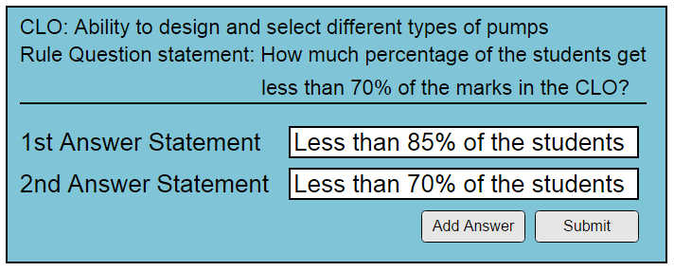

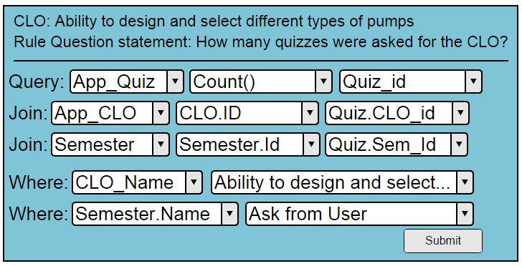

### Screen Fields

|  |  |  |
| --- | --- | --- |
| Field Name | Mandatory | Type |
| Rule Answer statement | Yes | String |

### Screen Actions:

|  |  |
| --- | --- |
| Action Name | Action to Perform |
| Add | Add a new rule answer, save the rule answer and show blank field to store one more rule answer |
| Submit | Add the rule question and answers in database |

## Use case - Add a rule

The user will first enter the rule statement; then the user will select the rule questions' answer. Each question along with its answer will be presented to the user.

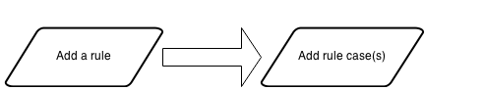

## Add a rule

This screen will be available to the expert. They may add a rule for improvement.

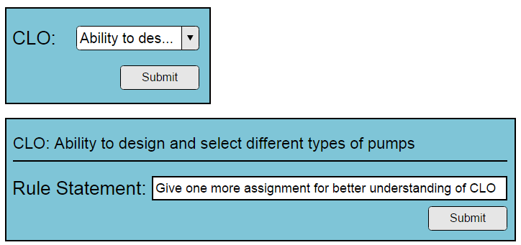

### Screen Fields

|  |  |  |
| --- | --- | --- |
| Field Name | Mandatory | Type |
| CLO | Yes | Drop Down Selection |
| Rule Statement | Yes | String |

### Screen Actions:

|  |  |
| --- | --- |
| Action Name | Action to Perform |
| Submit | Take the user to ask the attribute values for this question (screen: Add a rule case) |

## Add rule case(s)

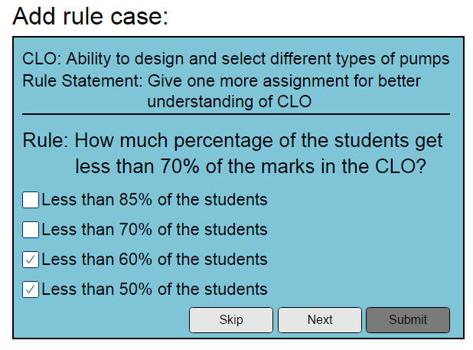

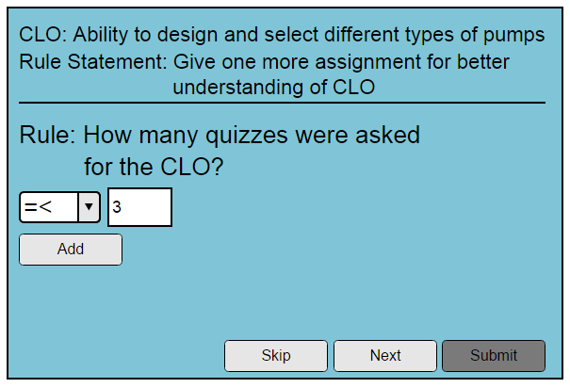

This screen will be available to the experts. When they will submit a rule, this screen will open, asking them to tell the rule cases. They may add rule cases for the new rule. One by one each rule question along with their answer will be presented to the user. He may skip the question or select answer(s).

### Screen Fields

|  |  |  |
| --- | --- | --- |
| Field Name | Mandatory | Type |
| Rule Question Statement | Yes | String |
| Rule Question Answer Section |  | Section |
| Answer Statement | No | Checkbox Selection (in list, showing all of the answers associated with the question) |

### Screen Actions:

|  |  |
| --- | --- |
| Action Name | Action to Perform |
| Skip | Clicking this button will not associate the current question with the rule and will show the next question (if any) for selection. If no more question exist, system will show a related message. |
| Submit | Add the rule along with the questions and their answers in database |

## Use case - Asking system for Improvement Suggestions

The user will select a CLO, then the system will show the all the rule questions and ask the user to select question's answer. When all the questions have been asked from the user, the system will perform inferencing on the basis of user input and then the system will show the suggestion for improvement in the selected CLO.

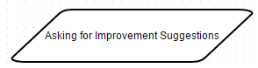

## Asking System for Improvement Suggestions

This screen will be available to the teachers/experts/moderator. They may ask the system for improvement suggestions. The rules along with their cases will be presented to the user, he may select that rule or skip it. The selected rule questions will become search criteria. All the rules which matches the search criteria will be shown to the user.

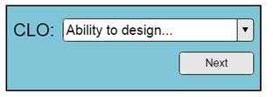

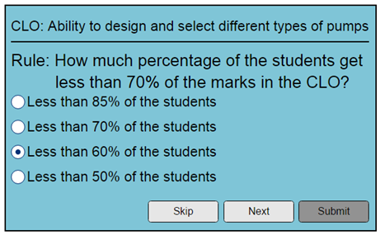

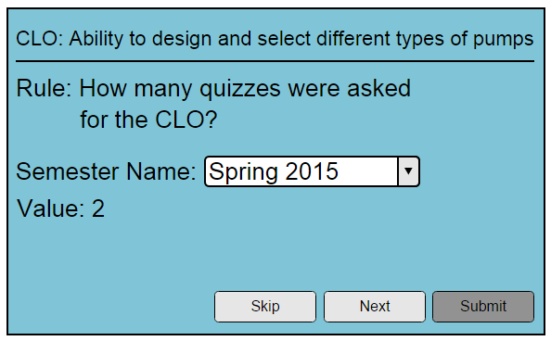

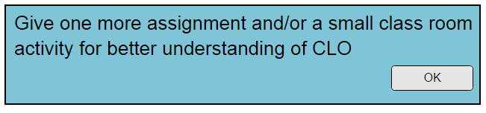

### Screen Fields

|  |  |  |
| --- | --- | --- |
| Field Name | Mandatory | Type |
| CLO | Yes | Drop Down Selection |
| Rule Question Statement | Yes | String |
| Rule Question's Answer Section |  | Section |
| Rule Question's Answer Statement | No | Radio Selection (in list, showing all of the answers options associated with the question) |

### Screen Actions:

|  |  |
| --- | --- |
| Action Name | Action to Perform |
| Skip | Clicking this button will not associate the current questions' answer with the search criteria and will show the next question (if any) for selection. If no more attribute exist, system will show a related message. |
| Submit | Suggest an improvement plan based on the processing done for the given search criteria. |

# Question Bank

## Use case - Add an attribute

In this use case the user will first add an attribute. Then user will add options associated with the added attribute.

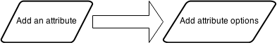

## Add an attribute

This screen will be available to the experts/moderator. They may add an attribute for the questions (in question bank)

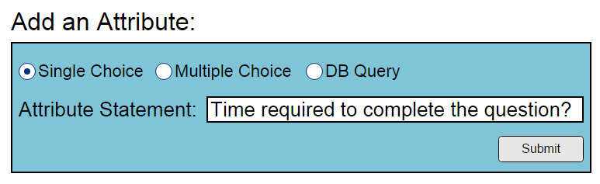

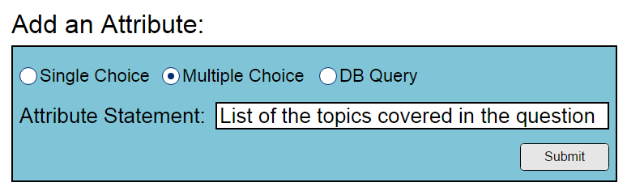

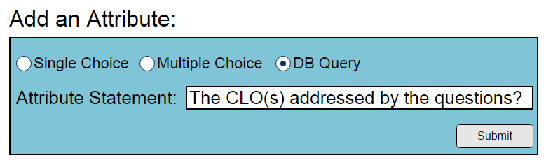

### Screen Fields

|  |  |  |
| --- | --- | --- |
| Field Name | Mandatory | Type |
| Attribute Statement | Yes | String |

### Screen Actions:

|  |  |
| --- | --- |
| Action Name | Action to Perform |
| Submit | Take the user to Attribute options screen |

## Add an attribute Options

This screen will be available to the experts/moderator. They may add an attribute option for the questions (in question bank)

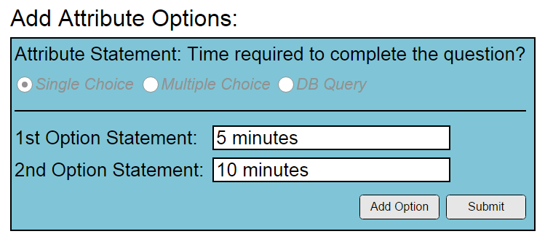

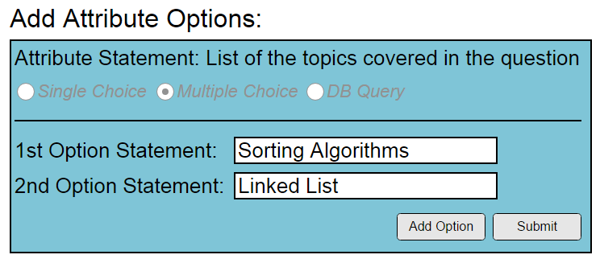

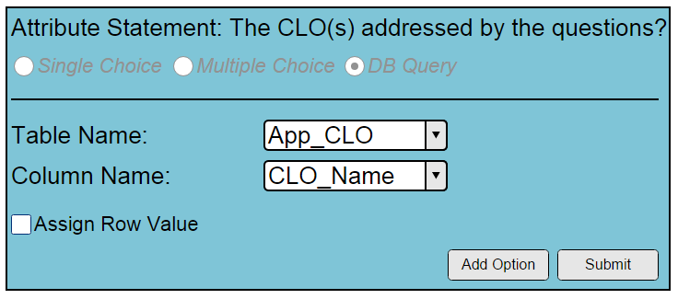

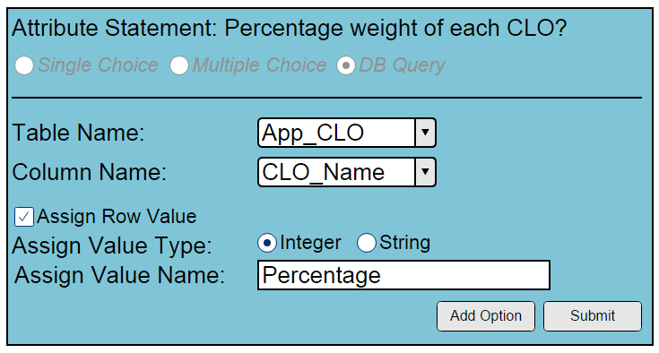

### Screen Fields

|  |  |  |
| --- | --- | --- |
| Field Name | Mandatory | Type |
| Attribute Option Statement | Yes | String |

### Screen Actions:

|  |  |
| --- | --- |
| Action Name | Action to Perform |
| Add | Add a new attribute option, save the attribute option and show blank field to store one more attribute option |
| Submit | Add the attribute and attribute options in database |

## Use case - Add a question

In this use case, first user will add a question, then the user will assign the attributes to the added question.

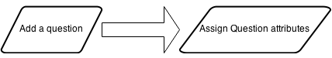

## Add a question

This screen will be available to the teachers/experts/moderator. They may add a question (in question bank)

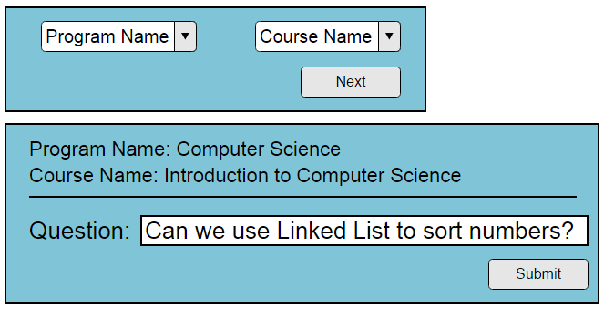

### Screen Fields

|  |  |  |
| --- | --- | --- |
| Field Name | Mandatory | Type |
| Program Name | Yes | Drop Down Selection |
| Course Name | Yes | Drop Down Selection |
| Question Statement | Yes | String |

### Screen Actions:

|  |  |
| --- | --- |
| Action Name | Action to Perform |
| Next | Take the user to ask the attribute values for this question (screen: Add a question attribute) |

## Assign question attribute(s)

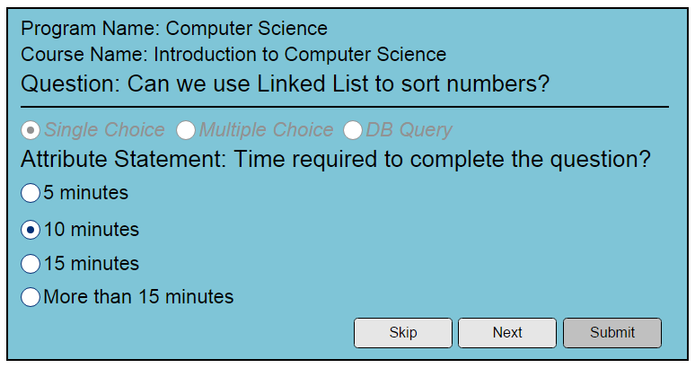

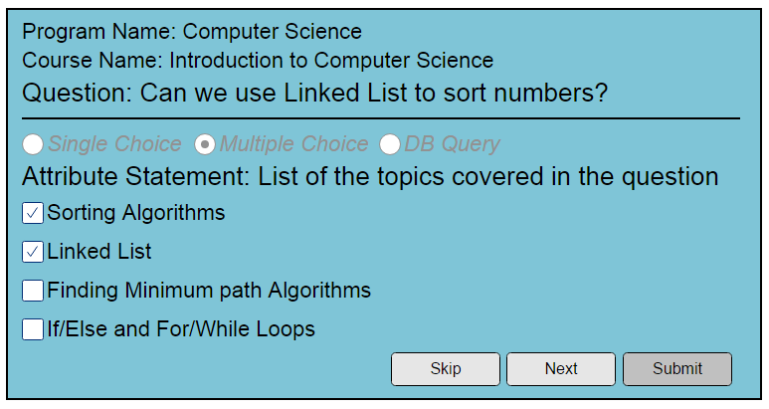

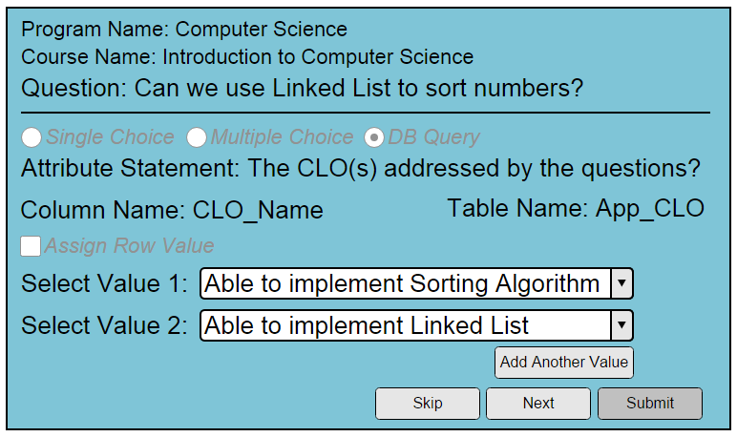

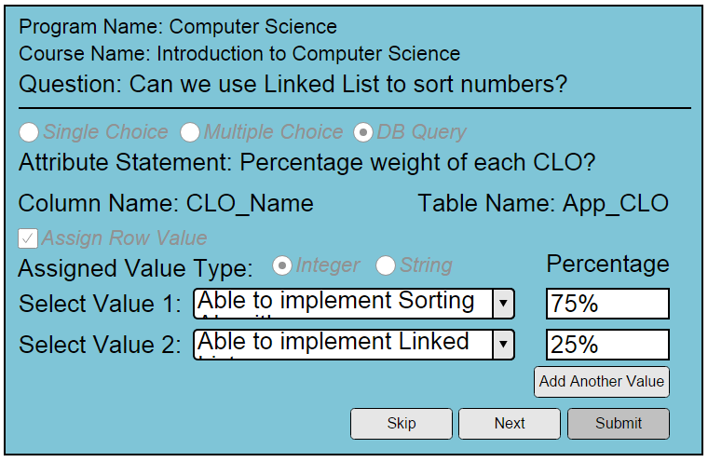

This screen will be available to the teachers/experts/moderator. When they will submit a question, this screen will open, asking them to tell the question attributes. They may add attributes for the question. One by one each attribute along with their attribute options will be presented to the user. He may skip the attribute or select attribute option(s).

### Screen Fields

|  |  |  |
| --- | --- | --- |
| Field Name | Mandatory | Type |
| Attribute Statement | Yes | String |
| Attribute Option Section |  | Section |
| Attribute Option Statement | No | Checkbox Selection (in list, showing all of the attribute options associated with the attribute) |

### Screen Actions:

|  |  |
| --- | --- |
| Action Name | Action to Perform |
| Skip | Clicking this button will not associate the current attribute with the question and will show the next attribute (if any) for selection. If no more attribute exist, system will show a related message. |
| Submit | Add the question along with the attributes in database |

## Use case - Add a favorite list

When a user will start creating a favorite list, the user will click on Add a Favorite List button from menu. Then the user will select the attribute options and then user will pick some/all question(s) from the questions suggested by Expert System.

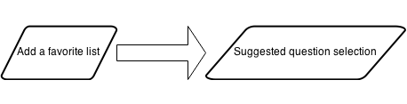

## Add a Favorite List

This screen will be available to the teachers/experts/moderator. They may create a custom list of questions to be used in any assessment method. The attributes of the question will be presented to the user, he may select that attribute or skip it. The selected attributes will become search criteria for the questions. All the questions which matches the search criteria will be shown to be selected by the user, the user will select the questions from suggested list of questions. And their selected questions will be saved in the form of favorite list. The user may see the favorite list later any time.

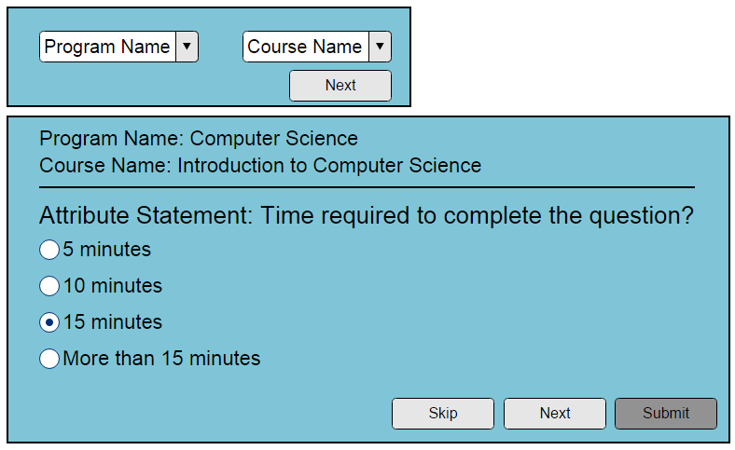

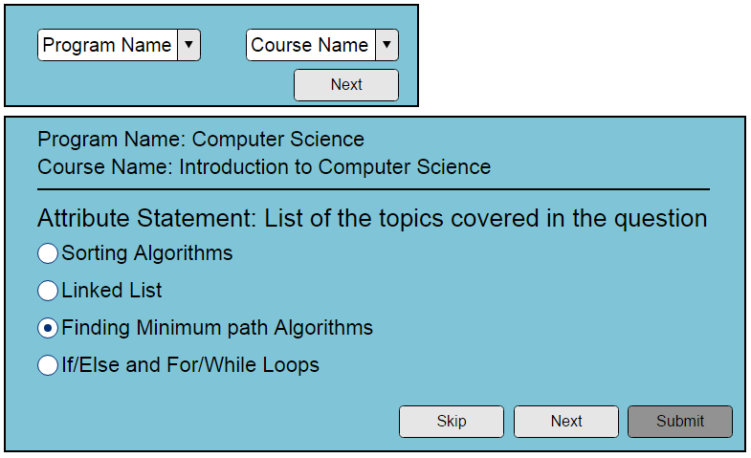

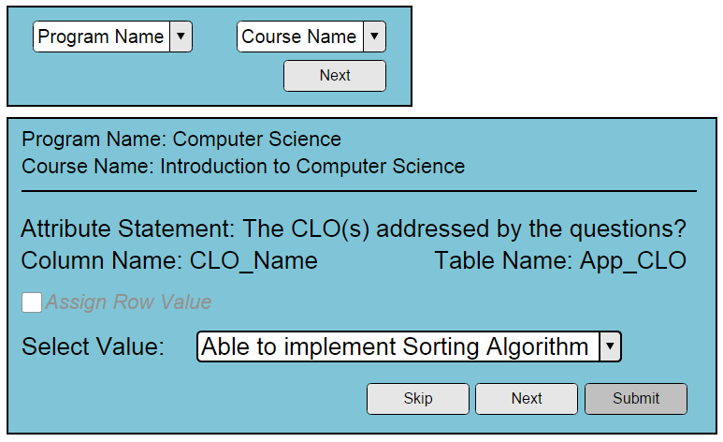

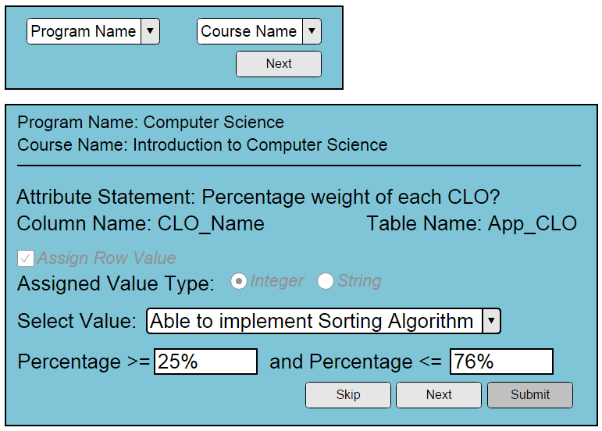

### Screen Fields

|  |  |  |
| --- | --- | --- |
| Field Name | Mandatory | Type |
| Program Name | Yes | Drop Down Selection |
| Course Name | Yes | Drop Down Selection |
| Attribute Statement | Yes | String |
| Attribute Option Section |  | Section |
| Attribute Option Statement | No | Radio Selection (in list, showing all of the attribute options associated with the attribute) |

### Screen Actions:

|  |  |
| --- | --- |
| Action Name | Action to Perform |
| Skip | Clicking this button will not associate the current attribute with the search criteria and will show the next attribute (if any) for selection. If no more attribute exist system will show a related message. |
| Submit | Show a list of suggested questions (described in screen name: suggested question for favorite list) |

## Suggested Questions Selection for Favorite List

This screen will be shown to the user after the user has selected and input the attribute options for the search criteria of a favorite list. The system will perform computation based on the search criteria and will show a list of the suggested questions. The user will have a check box along with each question to be selected.

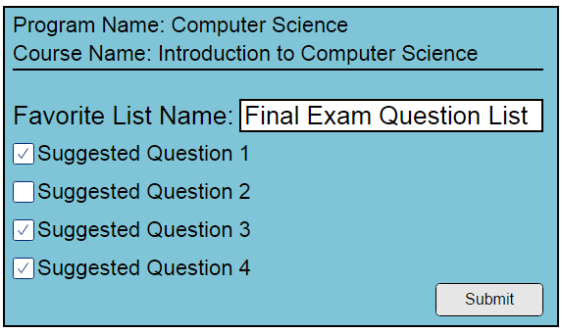

### Screen Fields

|  |  |  |
| --- | --- | --- |
| Field Name | Mandatory | Type |
| Favorite List Name | Yes | String |
| Question statement | Read-only | String |
| Selection Option | No | Checkbox |

### Screen Actions:

|  |  |
| --- | --- |
| Action Name | Action to Perform |
| Submit | The selected questions will be added to the favorite list and favorite list will be saved in the database for future use. |

# Data Dictionary

|  |  |  |  |  |
| --- | --- | --- | --- | --- |
| Table Name | Field Name | Data Type | Max Length | Is Nullable |
| App_Course | course_id | int | 4 | No |
| App_Course | App_Program_program_id | int | 4 | No |
| App_Course | course_name | varchar | 1 | Yes |
| App_Instructor | instructor_id | int | 4 | No |
| App_Instructor | instructor_name | varchar | 1 | Yes |
| App_Program | program_id | int | 4 | No |
| App_Program | program_name | varchar | 1 | Yes |
| I_CLO | clo_id | int | 4 | No |
| I_CLO | App_Course_course_id | int | 4 | No |
| I_CLO | clo_statement | varchar | 1 | Yes |
| I_Rule | rule_id | int | 4 | No |
| I_Rule | I_CLO_clo_id | int | 4 | No |
| I_Rule | rule_statement | varchar | 1 | Yes |
| I_Rule_Case | rule_case_id | int | 4 | No |
| I_Rule_Case | I_Rule_Ques_Answer_answer_id | int | 4 | No |
| I_Rule_Case | I_Rule_Question_rule_question_id | int | 4 | No |
| I_Rule_Case | I_Rule_rule_id | int | 4 | No |
| I_Rule_Ques_Answer | answer_id | int | 4 | No |
| I_Rule_Ques_Answer | I_Rule_Question_rule_question_id | int | 4 | No |
| I_Rule_Ques_Answer | answer_statement | varchar | 1 | Yes |
| I_Rule_Question | rule_question_id | int | 4 | No |
| I_Rule_Question | I_CLO_clo_id | int | 4 | No |
| I_Rule_Question | rule_ques_statement | varchar | 1 | Yes |
| Q_Attribute | attribute_id | int | 4 | No |
| Q_Attribute | attribute_statement | varchar | 1 | Yes |
| Q_Attribute | table_name | varchar | 1 | Yes |
| Q_Attribute | table_column_name | varchar | 1 | No |
| Q_Attribute_Options | attribute_option_id | int | 4 | No |
| Q_Attribute_Options | Q_Attribute_attribute_id | int | 4 | No |
| Q_Attribute_Options | option_statement | varchar | 1 | Yes |
| Q_Attribute_Options | table_row_id | int | 4 | Yes |
| Q_Attribute_Options | attached_value | varchar | 1 | Yes |
| Q_Favorite_List | favorite_list_id | int | 4 | No |
| Q_Favorite_List | App_Instructor_instructor_id | int | 4 | No |
| Q_Favorite_List | App_Program_program_id | int | 4 | No |
| Q_Favorite_List | App_Course_course_id | int | 4 | No |
| Q_Favorite_List_has_Q_Question | Q_Favorite_List_favorite_list_id | int | 4 | No |
| Q_Favorite_List_has_Q_Question | Q_Question_question_id | int | 4 | No |
| Q_Question | question_id | int | 4 | No |
| Q_Question | App_Instructor_instructor_id | int | 4 | No |
| Q_Question | App_Course_course_id | int | 4 | No |
| Q_Question | App_Program_program_id | int | 4 | No |
| Q_Question | question_statement | varchar | 1 | Yes |
| Q_Question | question_type | int | 4 | Yes |
| Q_Question_Attribute_Option | ques_att_option_id | int | 4 | No |
| Q_Question_Attribute_Option | Q_Attribute_Options_attribute_option_id | int | 4 | No |
| Q_Question_Attribute_Option | Q_Attribute_attribute_id | int | 4 | No |
| Q_Question_Attribute_Option | Q_Question_question_id | int | 4 | No |
| Q_Question_Attribute_Option | table_row_id | int | 4 | Yes |

# Database schema:

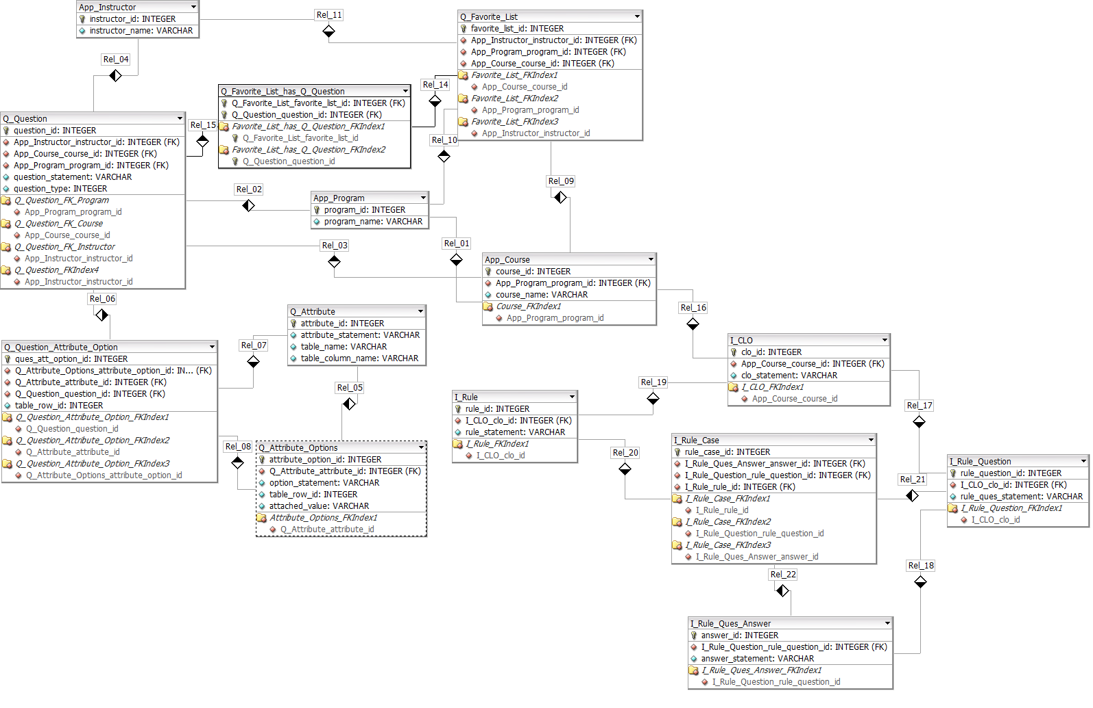

# Chapter 4 - Results

In this project we will be evaluating our system for 2 processes; one is for continuous quality improvement of the courses taught for ABET compliant teaching and evaluations which is outcome based teaching and learning and second for the questions bank which will help the instructor in designing more effective exams. Both of the processes will be created on the basis of expert system and decision based system. The industry experts will teach our system and the teachers would be using our system and taking benefits of the experts suggestion and input. We would evaluate our system in 2 courses being taught in some institute and evaluate the results against past performance.

# Chapter 5 - Conclusions and Future Work

Our system will allow the users to ask the suggestion for the improvement in the courses being taught by them. They may use this system for the preparing an exam. Industry experts will teach the system and their suggestion will help the users to get benefit from it. The expert system for improvement of the teaching a course has not been implemented earlier. The idea of integrating expert system with the question bank is also new.

# Chapter 6 - References

<The selected referencing format is Chicago Manual of Style (CMS). Help can be taken from: <http://www.chicagomanualofstyle.org/home.html>>

1. ABET SELF-STUDY REPORT (2013-2014 Review Cycle) for Civil Engineering Program at College of Engineering & Islamic Architecture Umm Al-Qura University Makkah Saudi Arabia.
2. Outcome Based Teaching and Learning in Computer Science Education at Sub degree Level by Gary K. W. Wong, Student Member, IEEE, Member, ACM and H. Y. Cheung
3. Knowledge management-enabled health care management systems: capabilities, infrastructure, and decision-support by Ranjit Bose
4. Creating and Coding an Expert System Using Visual Basic.NET by Brian Kovar.
5. Imam, M.H., Tasadduq, I.A., “Evaluating the Satisfaction of ABET Student Outcomes from Course Learning Outcomes through a Software Implementation”, International Journal of Quality Assurance in Engineering and Technology Education, 2(3), 21-33, July-September 2012.